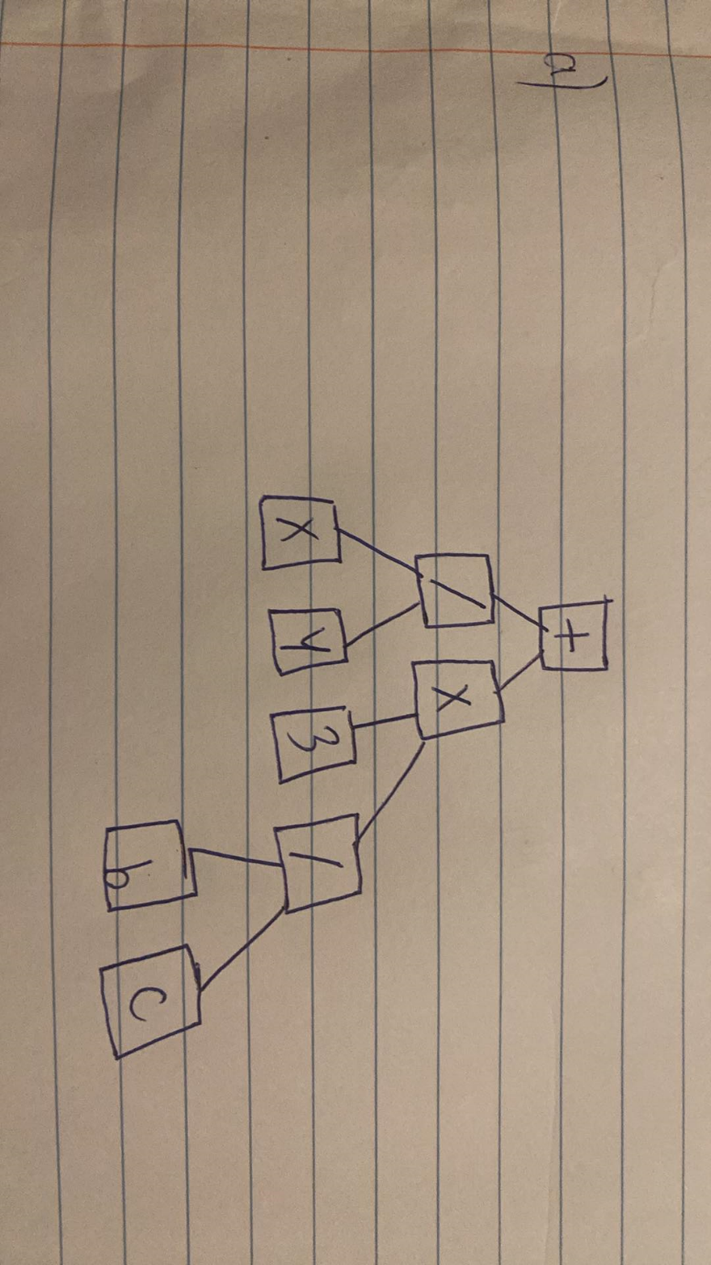

Name: Nguyen Quy Toan

Date: 11/27/2023

CS-303 Assignment 4

Q1:

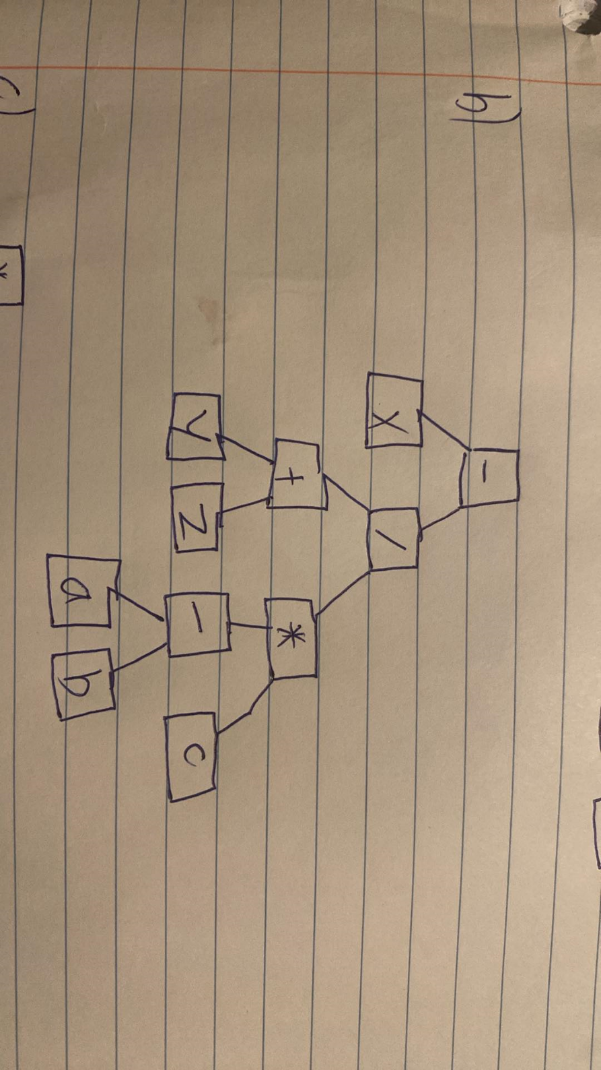

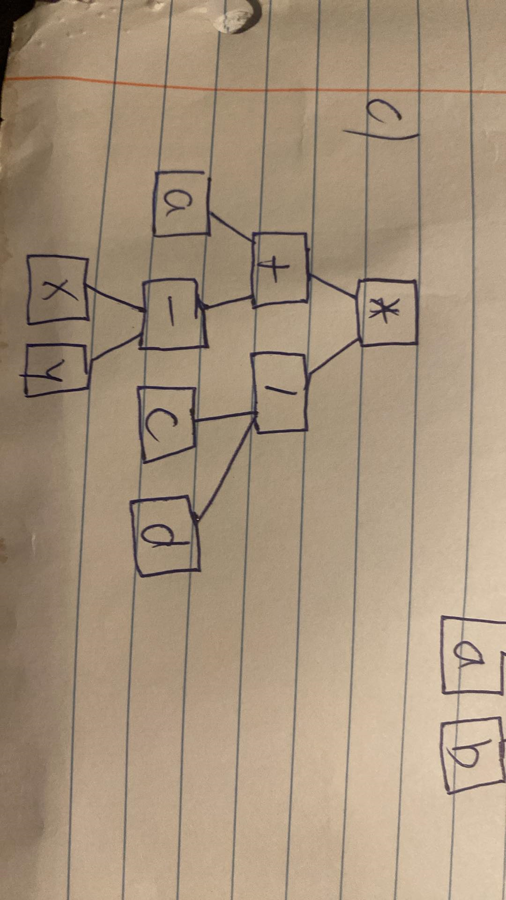

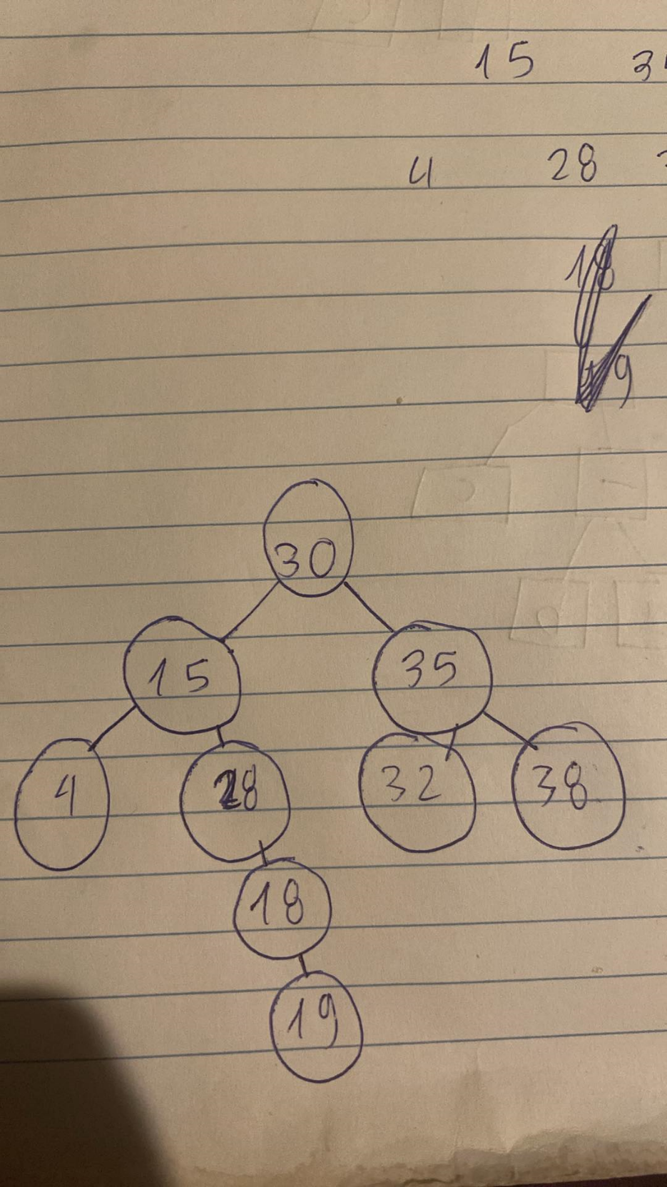

Q2:

The root is 30.

The left subtree of 30 contains nodes 15 and 20.

The right subtree of 30 contains nodes 35.

The left subtree of 15 contains node 4.

The right subtree of 20 contains nodes 18, which has a right child 19.

The left subtree of 35 contains nodes 32.

The right subtree of 35 contains nodes 38.